**Home Food Delivery App**

**By**

**Team 11**

**INDEX**

|  |  |
| --- | --- |
| Title | Sub Points |
| Introduction | 1. Problem Statement |
| 1. Project Objectives |
| 1. Project Scope |
| 1. Goals |
| Project Plan | 1. Project Plan |
| 2. Project roles and responsibilities |
| Requirement analysis | 1. Purpose |
| 2. Project features |
| 3. Tech Stack Used |
| Design Document | 1. Data formats and source code |
| 2. Development |
| 3. Testing |
| Future enhancements | |
| Summary | |
| Bibliography | |

**Introduction**

* Problem Statement:

Home food is an online food delivery portal where customers can find meals or food from any nearby restaurants. The idea is to serve food in minimum cost and provide good quality of service so that customers can eat a healthy food.

* Project Objective:

The main objectives of the project are as follows:

1. The user will be able to search the restaurants of his choice.
2. The user will be able to select food items and add to his cart.
3. To provide the online payment and Pay on delivery option to user so that user can make payment easily.
4. To provide sign up and sign in option so that user can get the offers and good service from our portal.
5. To provide Veg and Non-veg filter option so that user can find the food which they want.

* Project Scope:

The main objective behind our project is to provide the healthy food to the user in minimum cost. So that user can get the good quality of service and the food on time. And also to provide a filter option to the user so that they can find the food which they want. One more purpose is to save time of the user by placing the order on time with multiple payment options.

* Project Goal

The project goal is that we are making the online food delivery portal where customers can find meals or food from any nearby restaurants. The idea is to serve meals prepared by a family member so that customers can eat a healthy home-cooked meal. And also we are adding the online payment option so that user can pay online or they can pay on delivery.

**Project Plan**

We divided the project into 5 modules and all 5 members was working on it. In 1st week we completed the Landing page UI and also others completed their UI. In 2nd week we plan for make the database connection and build some remaining UI. In 3rd week we completed the Api calls and database connection. And finally in 4th week we are working on complete the reaming work.

**­**

**Project Roles and Responsibilities**

|  |  |  |
| --- | --- | --- |
| **Name** | **Roles** | **Responsibilities** |
| Vaibhav Shinde | Front End Developer/  Team Representative | Landing Page/  User Story 4 |
| Arbaj Shaikh | Front End Developer | User Story 1 |
| Shivani Dinde | Front End Developer | User Story 5/6 |
| Shubham Vibhute | Front End Developer | User Story 3 |
| Sneha Hanchate | Front End Developer | User Story 2 |

**Requirement Analysis**

* Purpose:

The main purpose of our project is to provide a healthy food to the user and also provide multiple payment options like online payment or pay on delivery options so that user can get the good service from our portal.

* Project features:

1. Easy search food.
2. Filter the food like veg or non-veg.
3. Sign up and sign in option to get best offers and quality service.
4. Multiple Payment options like online or Pay on delivery.

* Tech Stack

**       **

**HTML5 CSS3 Javascript React Redux Firebase MaterialUI Bootstrap**



**Fontawesome**

**Design Document**

* Data format and source code:

Github repository Link:

<https://github.com/vaibhavs127/HomeFoodApp>

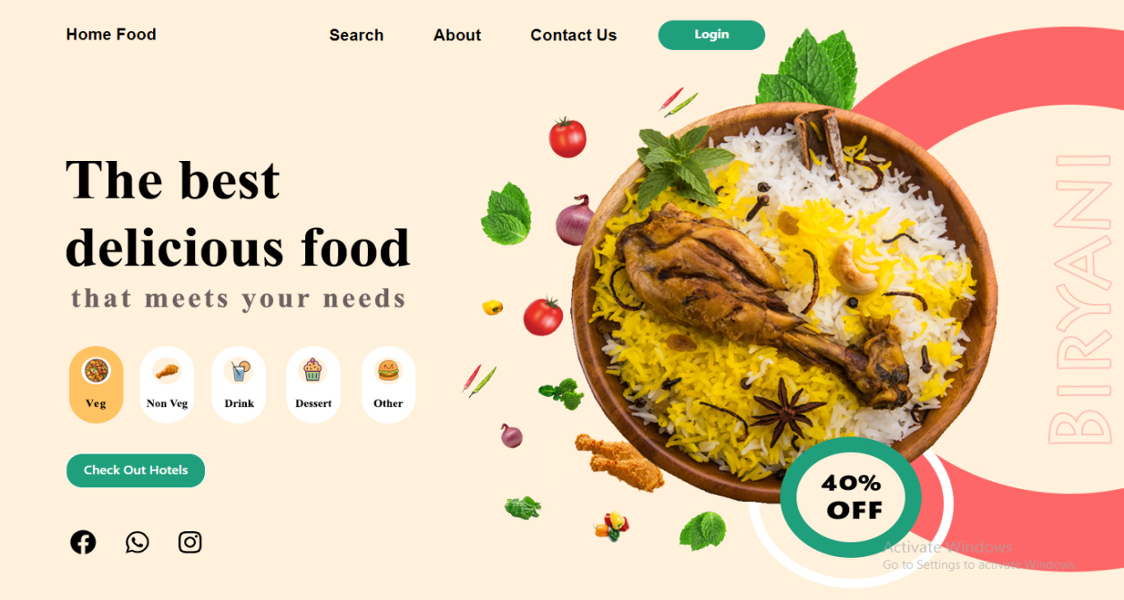

Fig: Landing Page

1. User Story 1:

As a user, I should be able to search the restaurant by the location or name, So that I can get the best results.

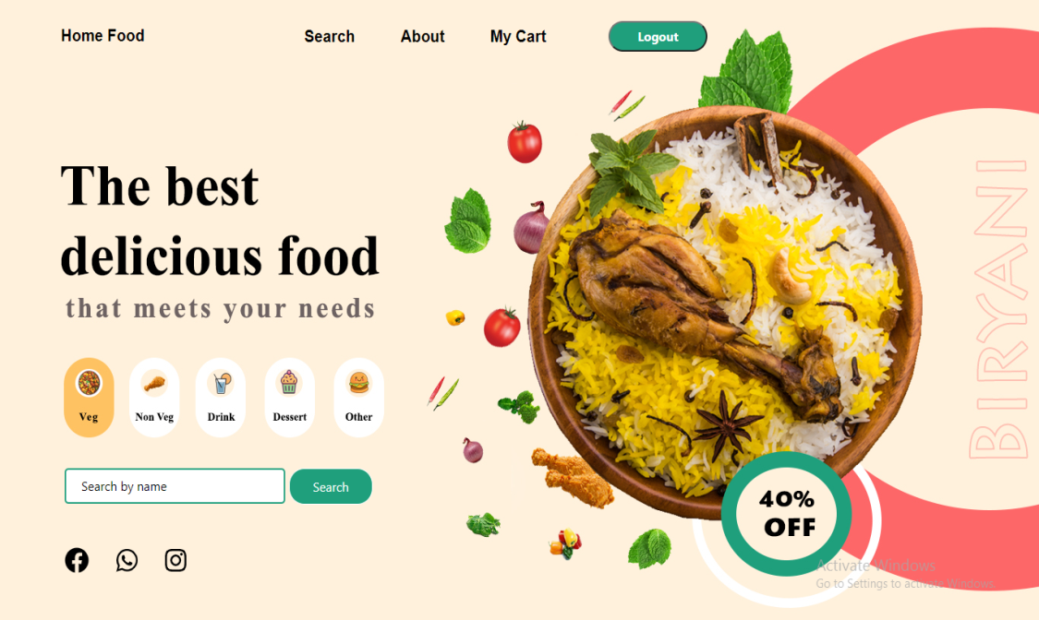

Fig: Search Form

1. User Story 2:

As a user, I should be able to see the list of restaurant based on my inputs, So that I can select the restaurant which is best for me and also select the food.

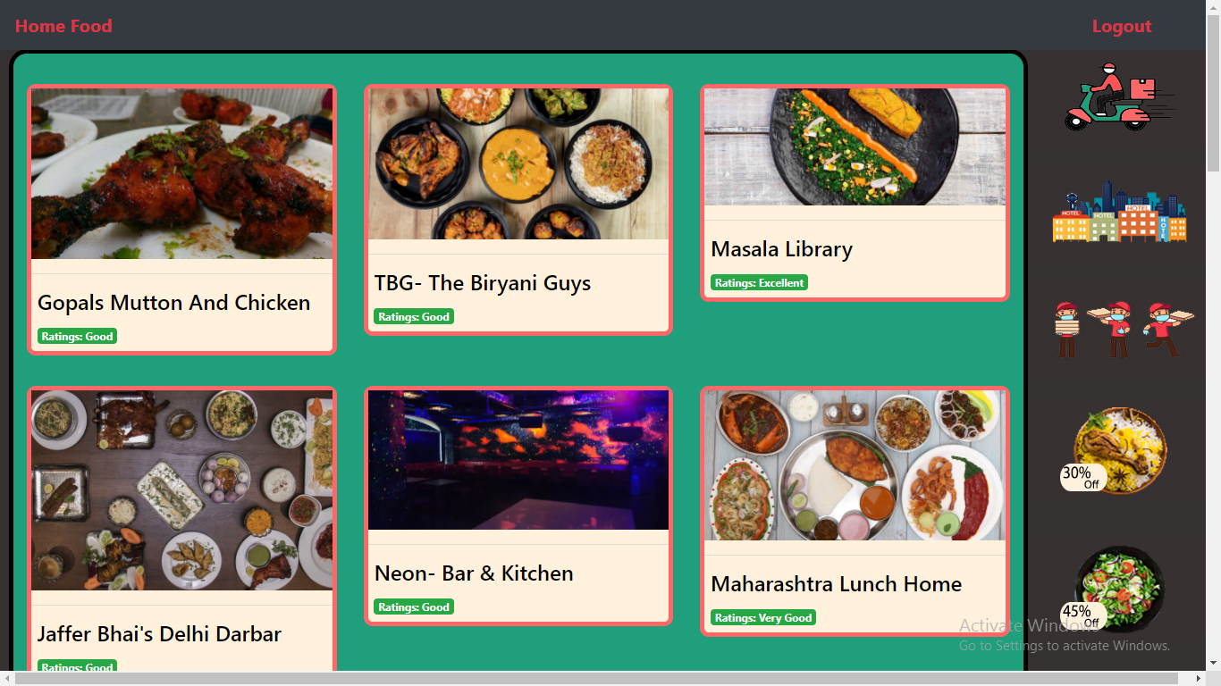

Fig: Search Result

1. User Story 3:

As a user, I should be able to see the list of cuisines offered by the restaurant and add the quantity after clicking on it, So that I can order food in a bulk of quantity.

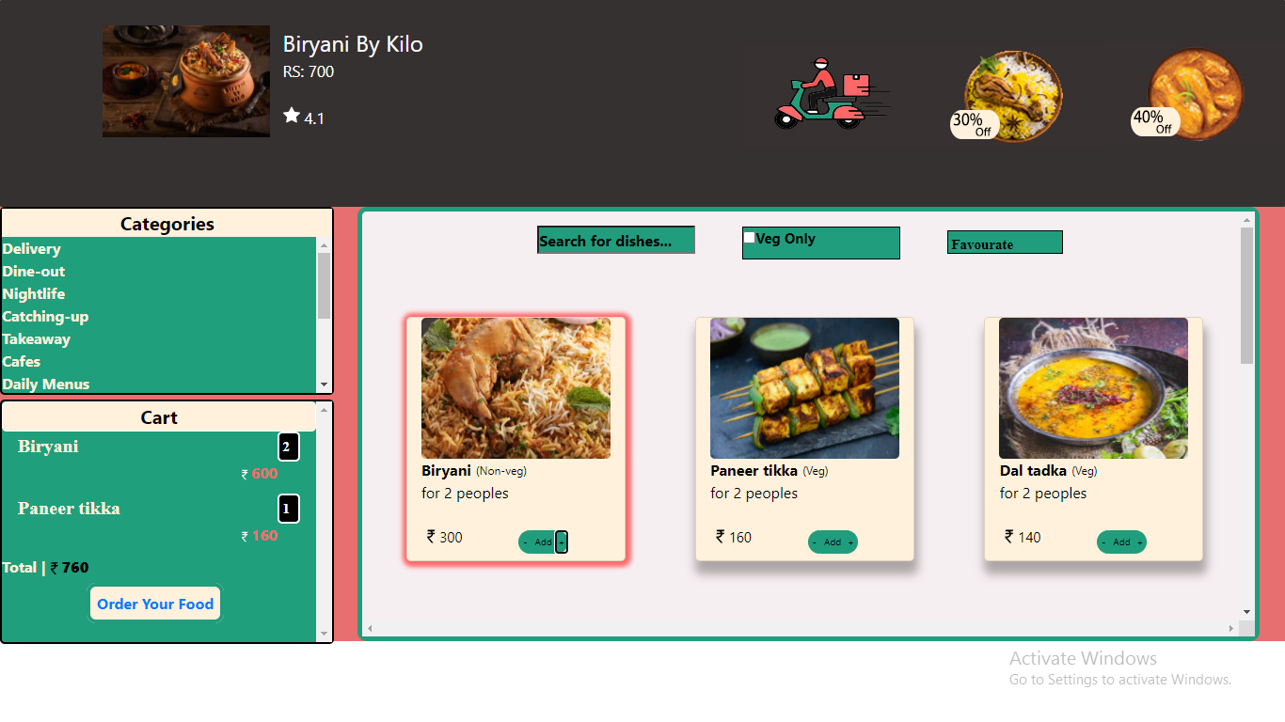

Fig: Hotel Information

1. User Story 4:

As a user, I should be able to sign in/sign up on to the portal and also I should be able to apply for resetting the password, So that I can get the best service from the portal.

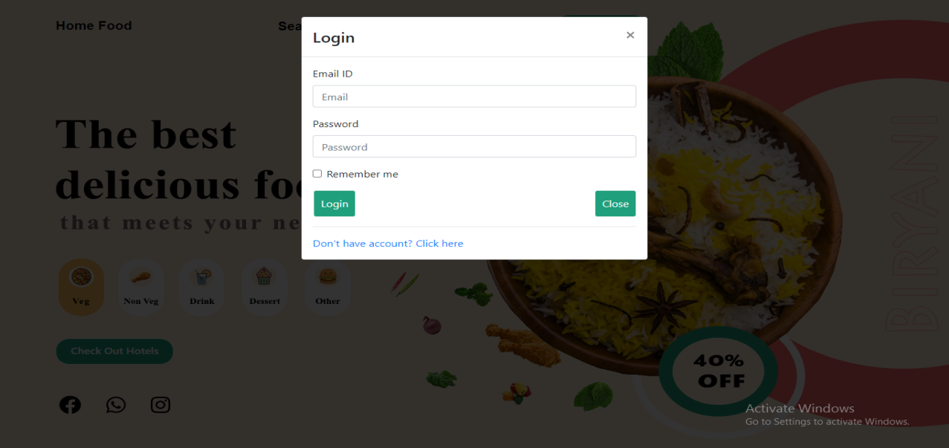

Fig: Login Modal

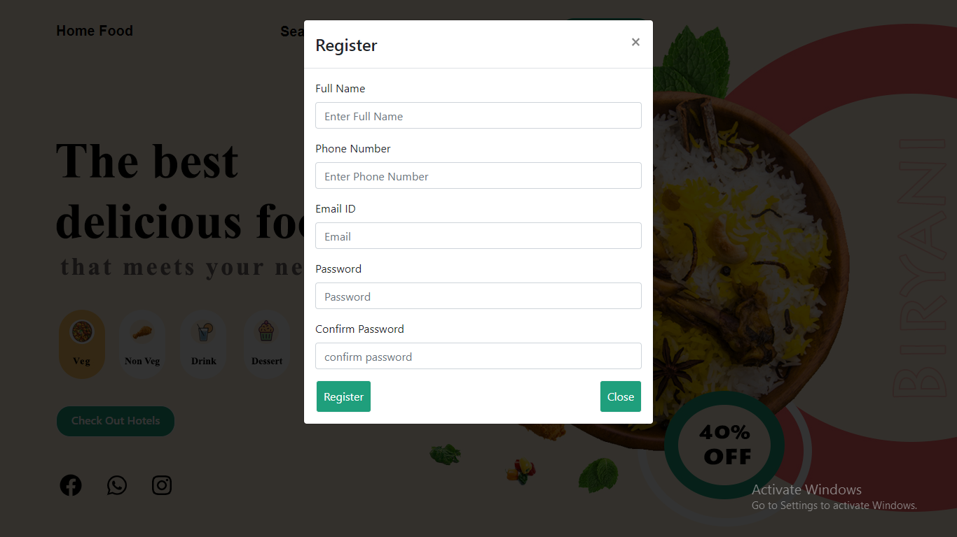

Fig: Registration Modal

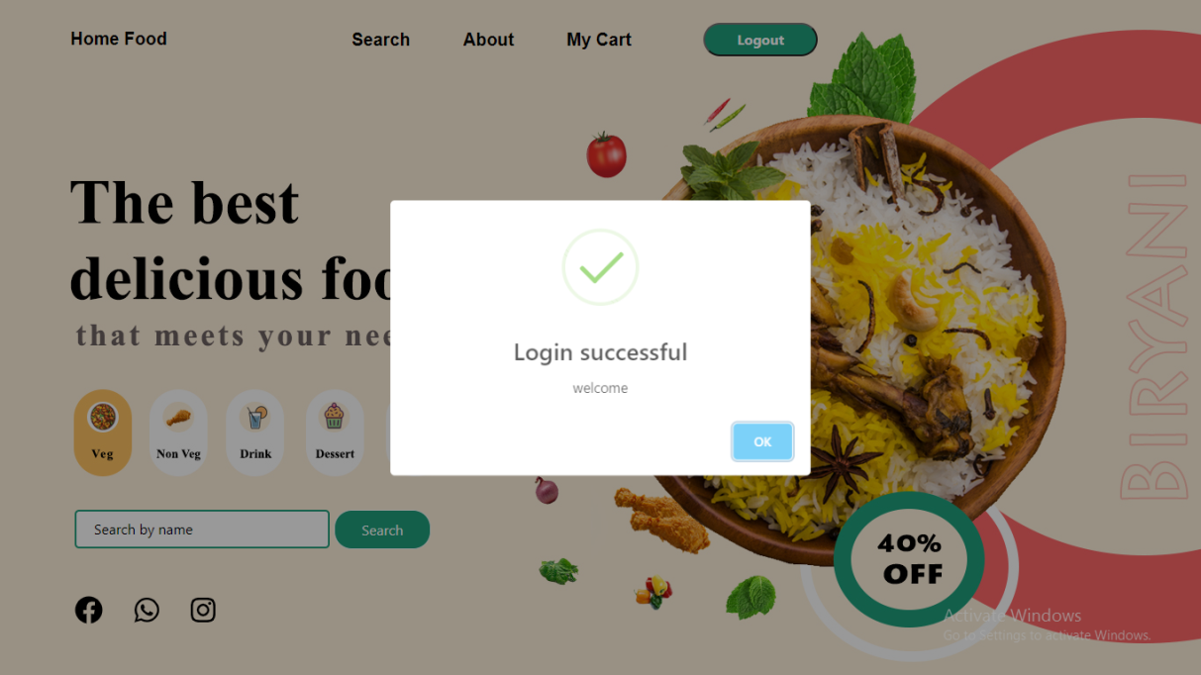

Fig: Login Successful

1. User Story 5:

As a user, I should be able to select the online payment or pay on delivery option, So that I can pay the bill and get the food.

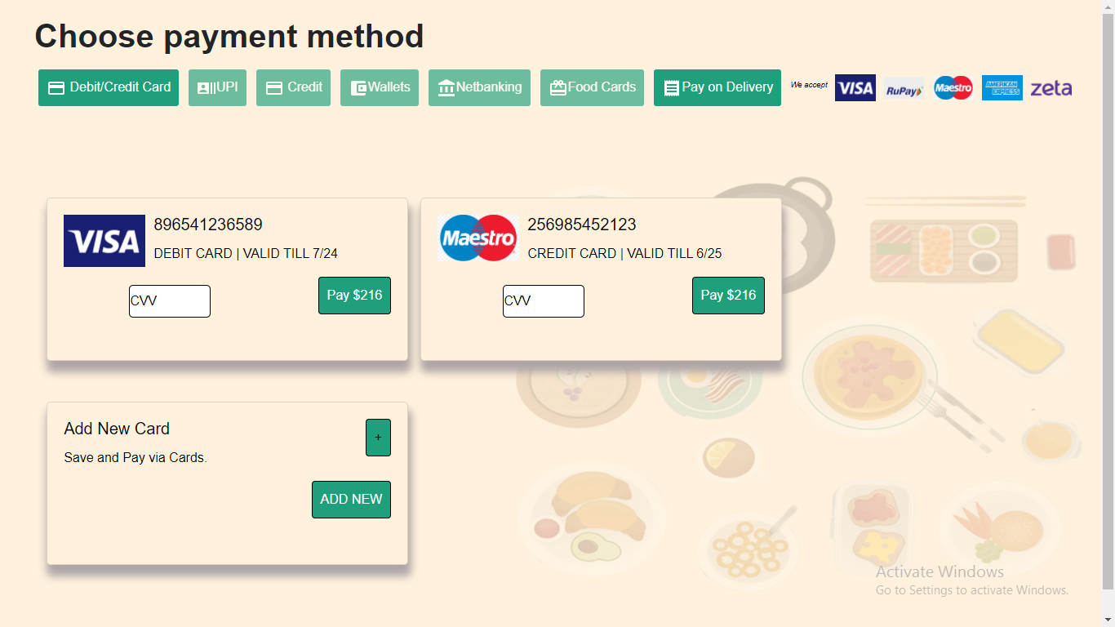

Fig: Payment

1. User Story 6:

As a user, I should be able to do the payment and place the order, So that I can eat the food which I ordered.

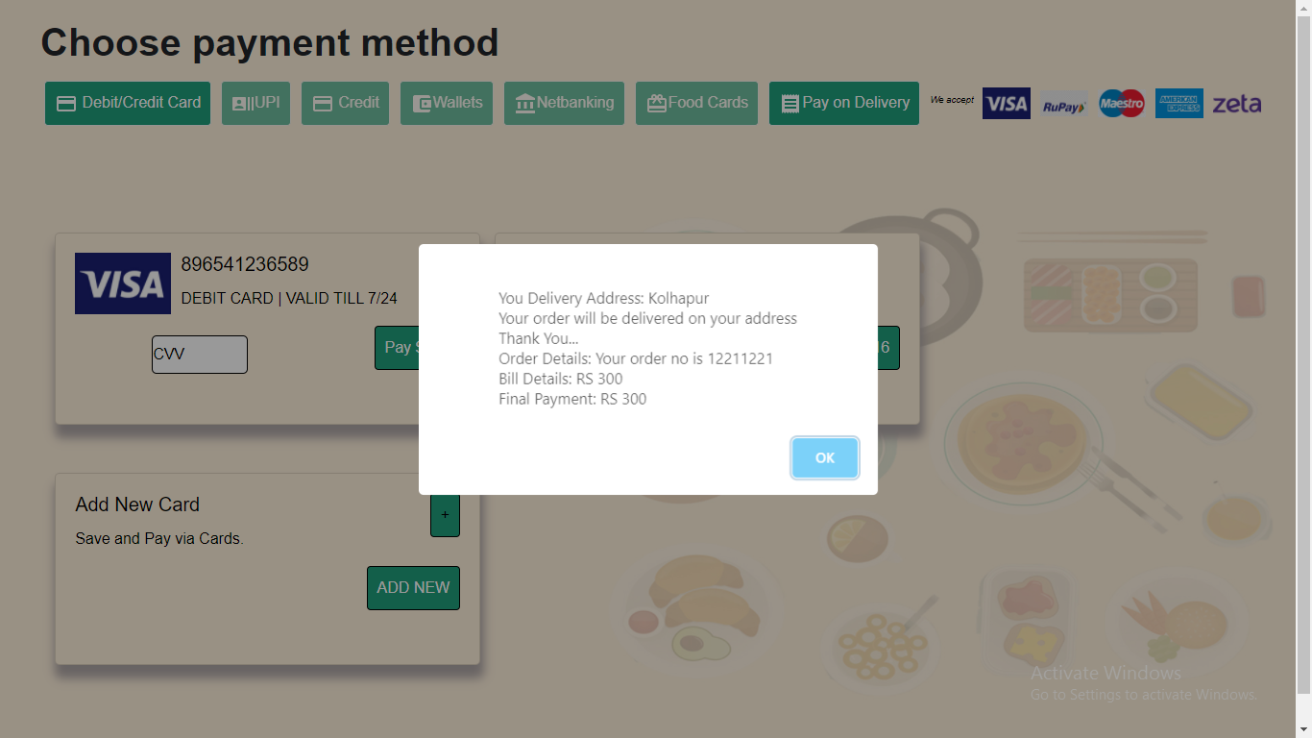

Fig: Order place Message

* Testing:

|  |  |  |  |  |
| --- | --- | --- | --- | --- |
| **Test case**  **ID** | **Test Case Description** | **Test item for which test case is**  **written** | **Precondition** | **Steps need to be done** |
| TC#1 | user should Register | Register Button | Registration page should be opened | Enter all required information  Click on Register Button |
| TC#2 | user should Register | Register Button | Registration page should be opened | only few fields are filled  Click on Register button |
| TC#3 | User should login to the  application | Login Button | Login page should be Opened | Enter correct username and password.  Click on Login button |
| TC#4 | User should search the food | Search Button | Search result should be opened | Entered correct name  Click on Search Button |
| TC#5 | User should get the hotel result | Result page | Search Hotels should be open with details | Click on Hotel Button |
| TC#6 | User should see the restaurants cuisine 1st | Hotel information page | Hotel cuisine should be opened | Click on hotel button then cuisine will be  open |
| TC#7 | User should filter the food | Get filtered food | Filtered result should be open | Click on filter button |
| TC#8 | User should select the food and can add the food into cart | Add food into the cart | Selected food can be added into the cart | Click on food which you want |
| TC#9 | User should make the payment for selected food | Open the payment page so user can make the payment | User should have the food item into the cart | Click on order food button |
| TC#10 | User should see the order placed message | Open the order placed message page | User should make the payment 1st | Click on Order button |

**Future enhancements**

The project has a very vast scope in future.

* We will be adding Location based cuisines.
* We will be adding live tracking system.
* Also we will provide More filter options to the user.

**Summary**

An Online food order system can simplify the hotels business as well as reduce the user waiting time with fast delivery. In our app user will get the hotels based on their search and also user can filter the cuisines as per their requirement. Also we provide the good and easy billing system user can pay online or can pay on delivery.

**Bibliography**

* <https://developers.zomato.com/documentation>
* <https://www.npmjs.com/package/@fortawesome/react-fontawesome>
* <https://material-ui.com/getting-started/installation/>
* <https://www.swiggy.com/restaurants>